**This Document for CI/CD pipeline**

Step 1

**Pull the images for NEXUS**

Podman pull sonatype/nexus3:latest

Step 2

**To create tar for the file**

Podman save -o nexus.tar sonatype/nexus3:latest

Step 3

**Send tar to server**

Scp nexus.tar developer@10.x.x.x

Step 4

**To load tar file**

Podman load -i nexus.tar

Step 5

Check the images

Podman images

Step 6

**To create a container**

podman run -itd --name nexus1 -p 8082:8081 -v /docker_volumes/nexus/data:/nexus-data sonatype/nexus3:latest

Step 7

Check the container is running

Podman ps

Step 8

For jenkins image i take images from etransport because the have all modules in there images

**Save the images to tar file**

Podman save -o jenkins1.tar localhost/jenkins_vahan:letest

Step 9

**To send the images to server**

Scp jenkins1.tar developer@10.x.x.x

Step 10

**To create a container for jenkins**

Podman run -itd --name jenkins1 -p 8080:8080 -v /var/run/docker.sock:/var/run/docker.sock -v /var/lib/docker:/var/lib/docker -v /docker_volumes/Jenkins_prod:/var/jenkins_home -v /usr/bin/docker:/usr/bin/docker -e "TZ=Asia/Kolkata" localhost/jenkins_vahan

Step 11

To check the container is running

Podman ps

Step 12

**Access the nexus in browser**

**For the you need to do port forwarding**

ssh -L 8082:10.x.x.x:8082 root@10.x.x.x

Step 13

Go to browser search menu and type

Localhost:8082

It visible like this

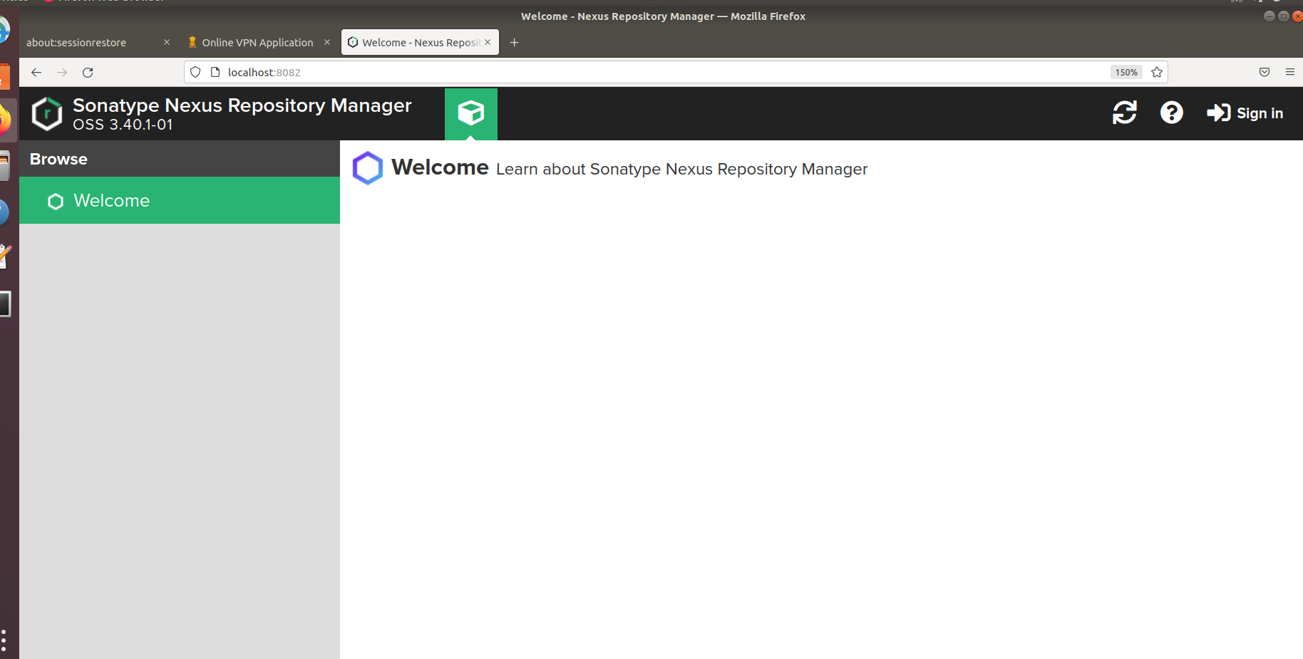

Step 14

Go to the sing in and sign up with

Username admin

Password admin

Step 15

For creating repository

Go to the setting and then repository

Then click on create new repository

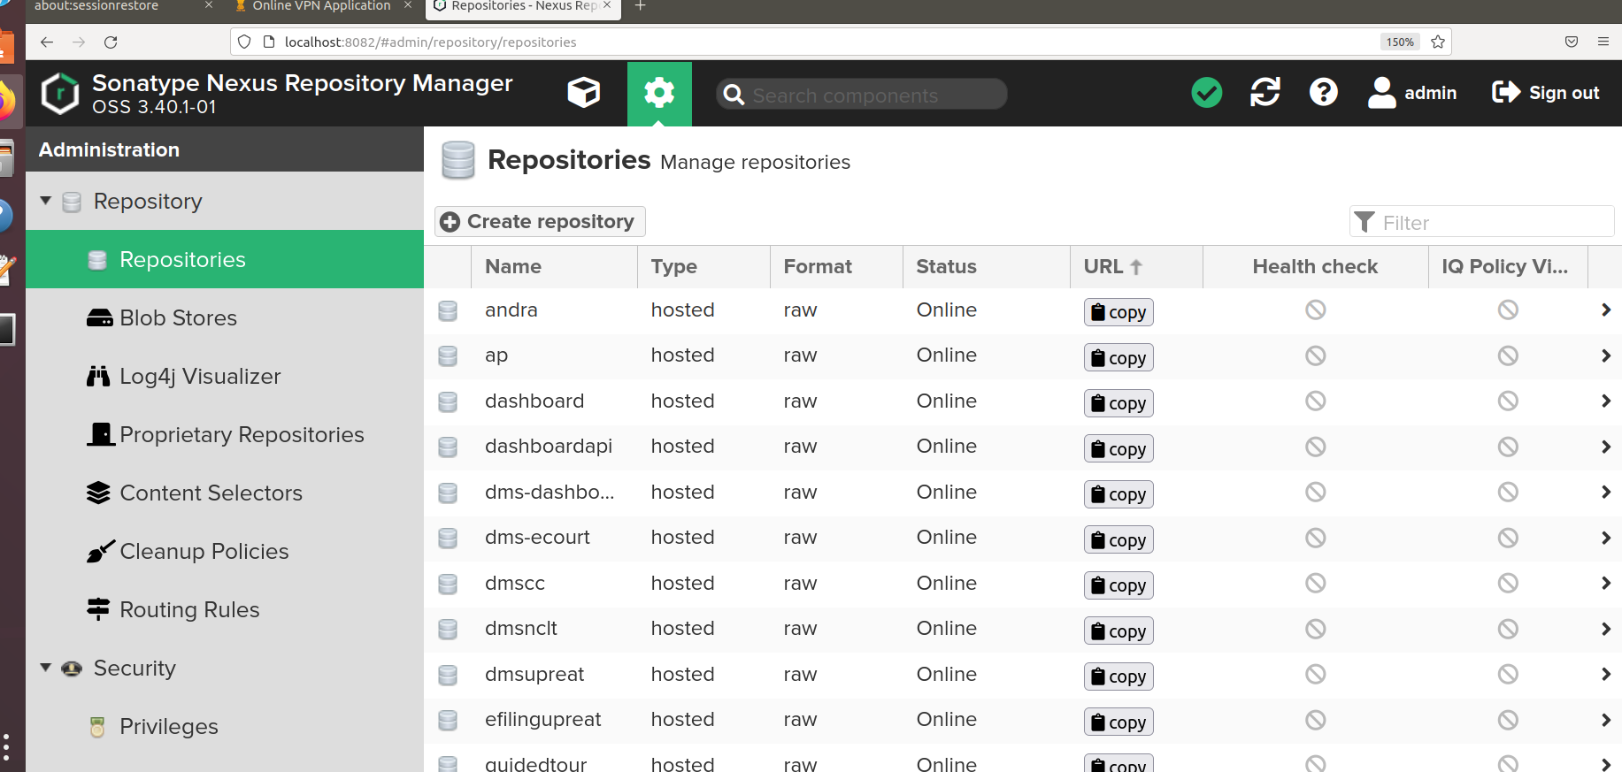

Step 16

Select raw(hosted)

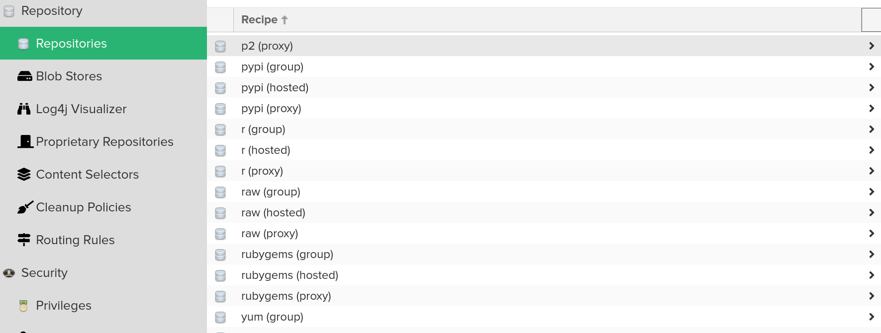

Step 17

Write the name and other details for the repository

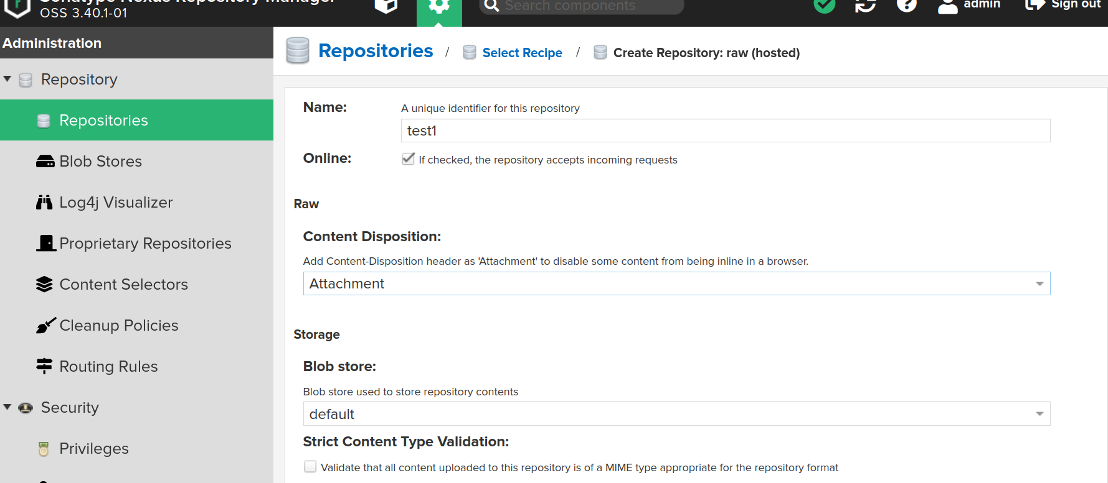

Step 18

Then click on create repository and repository is created

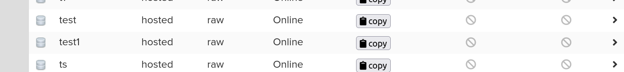

Step 19

You have to create roles

Go to the roles in the options

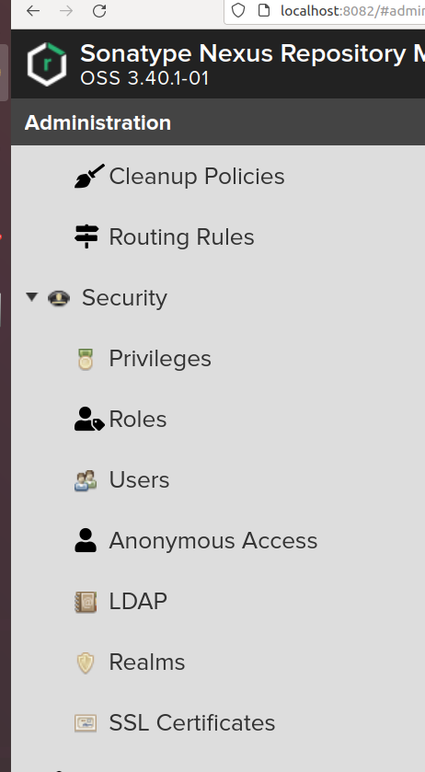

Step 20

Create a roles

Click on create roles and then select type nexus roles and add details

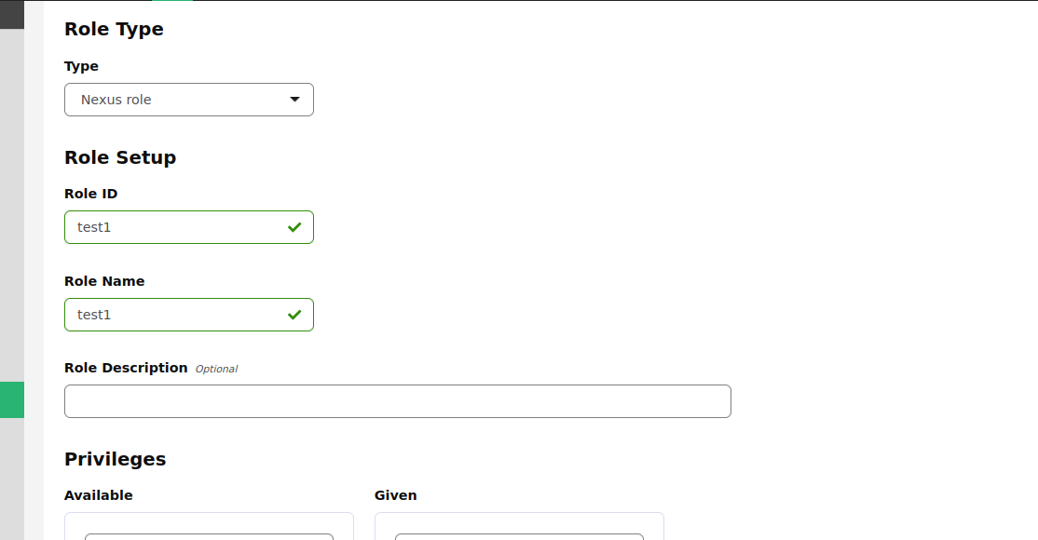

Step 21

Add privileges

These 2 privileges has to added

**nx-repository-admin-raw-test1-\***

**nx-repository-view-raw-test1-\***

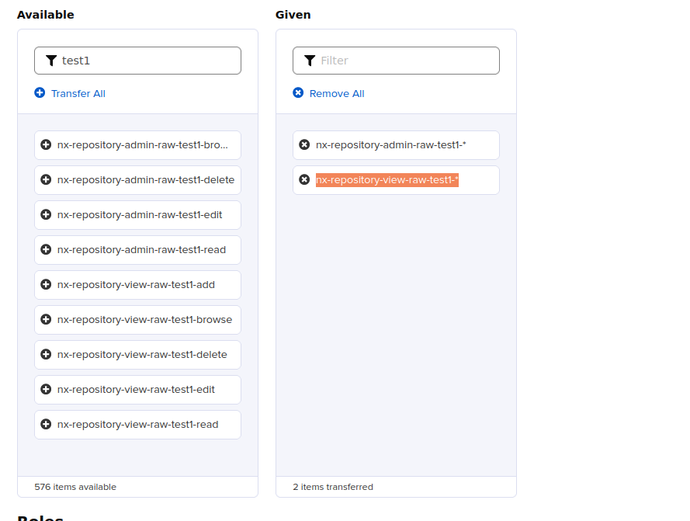

Step 22

Then click on save and your role has been created



Step 23

Now you have to create user

Select users in the option

Then click create local user

And add details

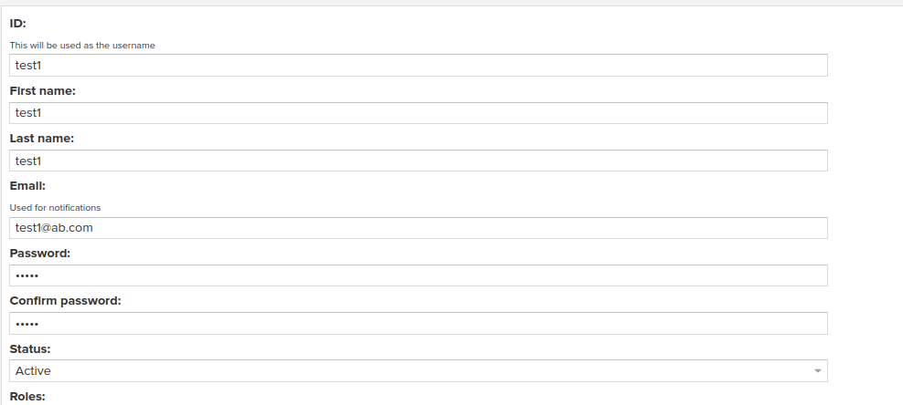

Password should be the same as username

In this case password should be **test1**

Step 24

Then grand roles to the user then click on create local user

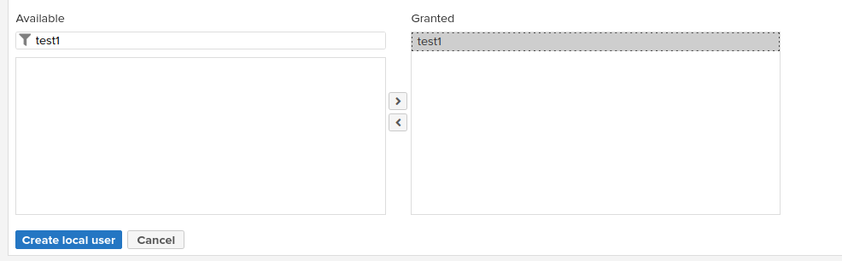

Step 25

To create pipeline in jenkins

Port is not opened you have to do port forwarding

ssh -L 8080:10.x.x.x:8080 root@10.x.x.x

Jenkins will open like this

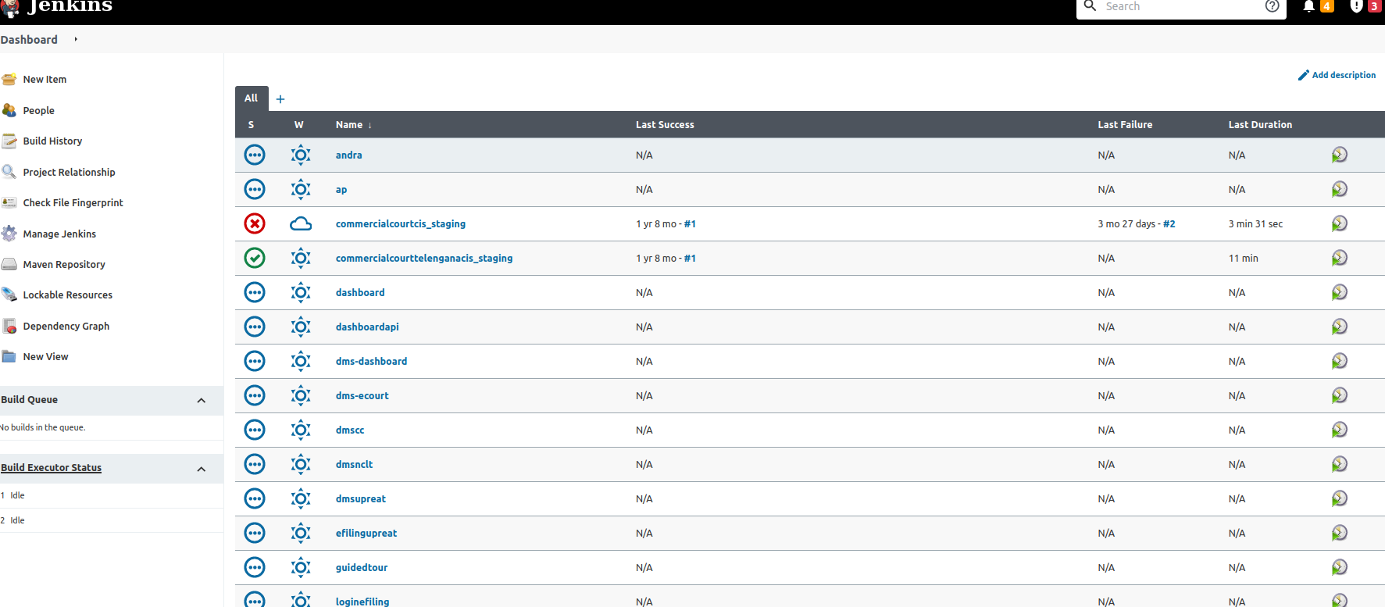

Step 26

To create pipeline click on new items in option

Then write pipeline name and select pipeline option

Add this pipeline script in pipeline option

pipeline {

agent any

stages {

stage('Deployment of test1 WAR') {

steps {

sh ''' ansible-playbook /var/jenkins_home/jenkins/ansible/test1.yml -i /var/jenkins_home/jenkins/ansible/inventory --private-key=/var/jenkins_home/jenkins/ansible/keys/ansibleadm --user jenkins'''

}

}

}

}

Then click on save

Step 27

Write a ansible playbook

Location- /docker_volumes/Jenkins_prod/jenkins/ansible

Create test1.yml at this location

vim test1.yml

---

- name: role

hosts: test1

roles:

- test1

~

Location- /docker_volumes/Jenkins_prod/jenkins/ansible/roles

Create a directory with same name test1

Mkdir test 1

And inside test1 create default and task directories

Location - docker_volumes/Jenkins_prod/jenkins/ansible/roles/test1/defaults

Vim main.yml

---

tomcats:

- name: 'test1'

tomcat_name: 'test1'

war_name: 'test1'

server_name: 'nq73p-nclt1-002'

backend_name: 'test1'

repository_url: "http://10.247.200.134:8085/repository/test1/test1/"

repository_username: 'test1'

repository_password: 'test1'

Location- /docker_volumes/Jenkins_prod/jenkins/ansible/roles/test1/tasks

Vim main.yml

---

#tasks:

- name: Create a directory if it does not exist

file:

path: /home/developer/test1

state: directory

owner: developer

group: developer

mode: '0755'

- name: Download Latest WAR

get_url:

url_username: "{{ item.repository_username }}"

url_password: "{{ item.repository_password }}"

#url: "{{ item.repository_url }}{{ date }}/{{ item.war_name }}.war"

url: "{{ item.repository_url }}{{ item.war_name }}.war"

owner: developer

group: developer

dest: "/home/developer/test1/"

with_items:

- "{{ tomcats }}"

register: download_status

- name: Create a directory if it does not exist

file:

path: "/opt/test1{{ansible_date_time.date}}"

state: directory

owner: developer

group: developer

mode: '0755'

- name: execute the command

become: true

become_user: developer

shell: podman cp test1:/usr/local/tomcat/webapps/test1 /opt/test1{{ansible_date_time.date}}

- name: execute the command

become: true

become_user: developer

shell: podman stop test1

- name: execute the command

become: true

become_user: develoepr

shell: podman rm test1

- name: build the image

become: true

become_user: developer

command: sh /home/developer/build.sh

- name: create container

become: true

become_user: developer

command: sh /home/developer/test1.sh

Run the pipeline

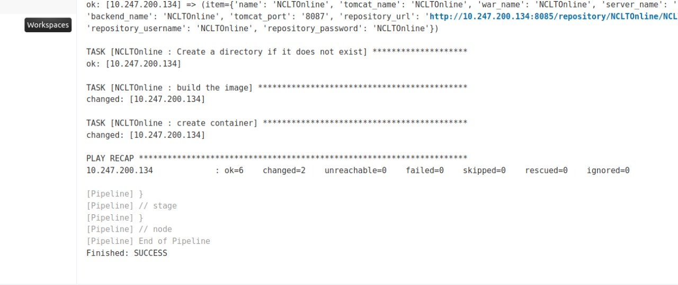

cat build.sh

#!/bin/bash

#f [ $# -eq 0 ]; then

# echo "No arguments provided. Pls provide Pod Tag version to start"

# exit 1

#fi

PODVERSION=`date +%d%h%Y`

MYNAME=${PWD##*/}

MYLOWERNAME=`echo $MYNAME | tr '[:upper:]' '[:lower:]'`

docker build -f Dockerfile -t nclatonline/$MYLOWERNAME-tomcat-9.0.65:$PODVERSION .

cat NCLTOnline1.sh

docker run -itd --name NCLTOnline1 -p 8088:8080 -v /Efile_Document:/Efile_Document -e "TZ=Asia/kolkata" --add-host=bharatkosh.gov.in:164.100.78.112 --add-host=sbox.nesl.co.in:182.18.150.111 --add-host=efiling.nclt.gov.in:164.100.59.89 --add-host=pg.meeseva.telangana.gov.in:103.122.128.44 --add-host=tsstaging.meeseva.telangana.gov.in:103.122.128.114 ncltonline1/developer-tomcat-9.0.65:`date +%d%h%Y`

cat Dockerfile

FROM [docker.io/library/tomcat:9.0.65-jdk11-openjdk](http://docker.io/library/tomcat:9.0.65-jdk11-openjdk)

COPY ncltonline1.war /usr/local/tomcat/webapps